WEEK - 8
Yash Raj
SuperSet ID - (6364442)

Git-HOL
Installing Git

Configuring the username and user-email
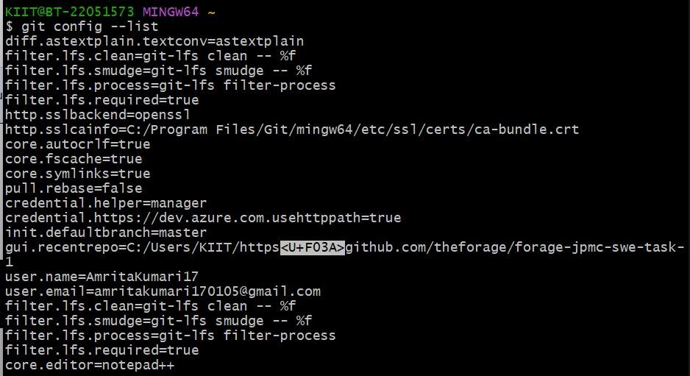
Initializing git and creating file
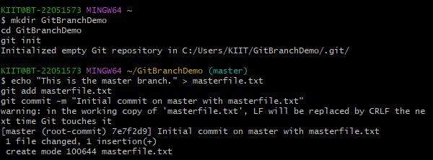

Branching:
  - Create a new branch “GitNewBranch”.

  - List all the local and remote branches available in the current trunk. Observe the “*” mark which denote the current pointing branch.
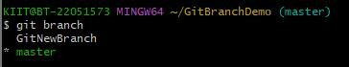
  - Switch to the newly created branch. Add some files to it with some contents.
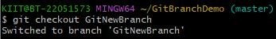
  - Commit the changes to the branch.
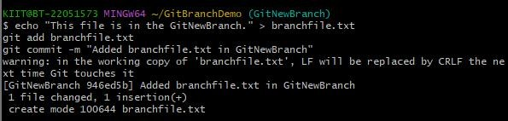
  - Check the status with “git status” command.
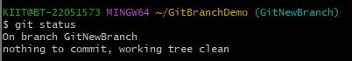

Merging:
- Switch to the master
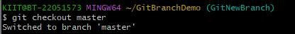
- List out all the differences between trunk and branch. These provide the differences in command line interface.
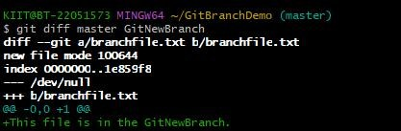
- List out all the visual differences between master and branch using P4Merge tool.
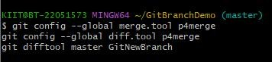
- Merge the source branch to the trunk.
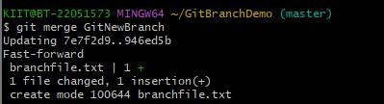
- Observe the logging after merging using “git log –oneline –graph –decorate”
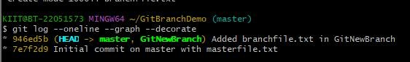
- Delete the branch after merging with the trunk and observe the git status.
